JOHN’S TRAVEL DIARIES

Readers may not be aware that John has kept diaries of most of his travels, in fact from a very early age. It began in the early 1960s and has continued unabated to the current day. In as many trips as possible, John was keen that each experience be recorded as it happened, rather than as an afterthought. As a result, the writing matures with time, beginning with youthful exuberance, later in a more introspective and sometimes comical imitation of a Clive James travel log, and finally reflecting age, and perhaps greater thought and literary polish. Throughout, they brim with literary quotations, music favoured at the time and images, many showing their age and poorer quality.

Online publication commenced early in 2025 and is ongoing. The diaries, many early ones hand written, had to be digitised using a spoken compiler and then assembled into logical groups which, so far, look as follows:

The Wandering Pilgrim

* Volume 1 Mountaineering expeditions
* Volume 2 Tasmanian walks, rafting and kayaking
* Volume 3 Boyhood travels and work travel abroad

The Wandering Pilgrim Volume 1



It can be found at any online bookstore such as *Booktopia Dymocks or Amazon*. Search for the ISBN 978-1-922958-96-9 or search the book title and scroll down through the many titles of the same name.

The Wandering Pilgrim Volume 2

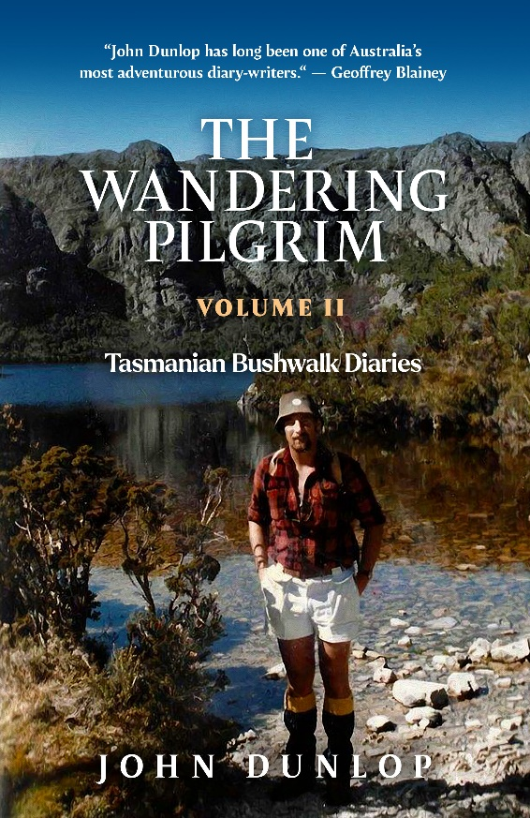

Volume 2 is online now and can be searched for the same way, but using the unique ISBN

9 781764 190565

The Wandering Pilgrim Volume 3

This third volume is in two parts, Part 1: boyhood travels and Part 2: Work related travel to far away places. It is planned to be ready to go online by the end of 2025.